## Lesson 8 – Activity Sheet

## Getting Started

## Due to a limitation with pins the Bit:Bot can only use one light sensor at a time.

## Pin 16 has to be written as a digital 1 or 0 depending on which sensor you wish to use with the analogue value being read from Pin 2

## This obviously causes some difficulties but has been simplified using the Bit:Bot extension with a single block being use to both enable and read from the sensor

## The analogue light sensor works by detecting the environmental light using an analogue scale of 0 (pitch black) to 1023 (max brightness)

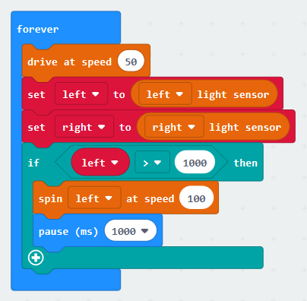

Remember – using the sensor in a bright room reduces the range of values the sensor can detect as it is already reading a high value from background light

## Success Criteria

* Use sensors to detect the environment
* Use code to take a reading from the light sensor
* Use selection to change actions based on a sensor reading

## Pro-tip

## Consider the light level in the room, this will impact what the sensor is already reading. Start high and work down – Identify the lowest value you can use that is not affected by background lighting

## Test Time

## Does the robot turn towards and away from a light using single sensor?

* Does the robot turn towards and away from the light using both sensors?
* How much does the light sensor get affected by room lighting?
* What will the impact of room lighting be on the ability of the robot to detect light sources?

## Stretch Tasks

* What impact does the drive speed have on the reaction time of the light sensor?
* Experiment with different light sources. How does the light sensor react or infrared (remote controls) or laser pointers
* Document your research for different coloured lights

## Final Thoughts

Today we have looked at the light sensor, we have learned how to enable each sensor using a digital input and how we can read in the analogue value and make decisions based on the value we have read in.

We have looked at the simplified version of the sensor blocks and how this makes reading the values easier.

We have also looked at how environmental factors impact on the light sensor and how we can use other targeted light sources such as infrared.